STQA PRAC 5

Steps to perform the practical:

1.Open any IDE

2.Have a folder structure as shown in the pic below (env folder is not needed)

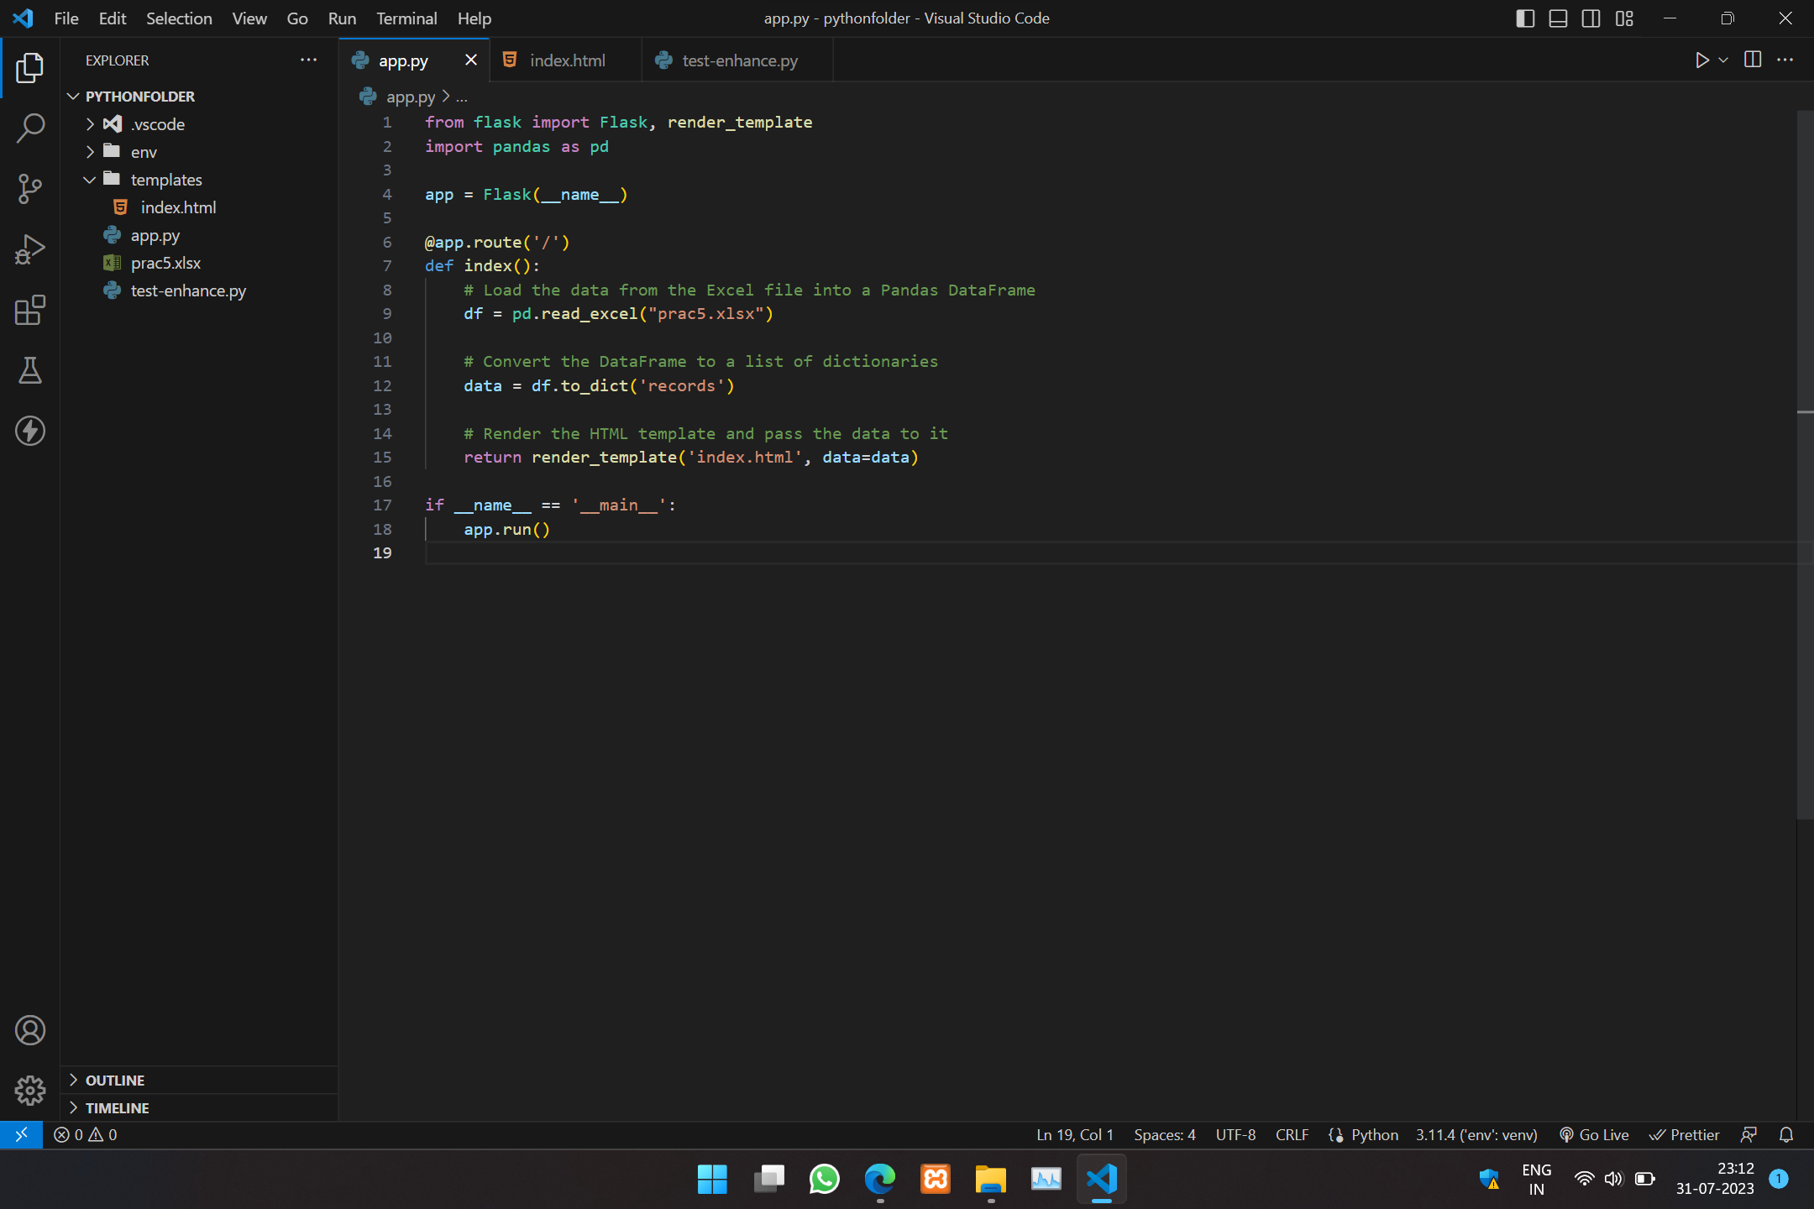

The structure is rigid don’t try to change the structure

3. Create 3 files as shown in picture app.py , test-enhance.py, templates-> index.html

4. Install the following python packages shown in the file and not in cmd prompt before proceeding (pandas,openpyxl,flask,selenium)

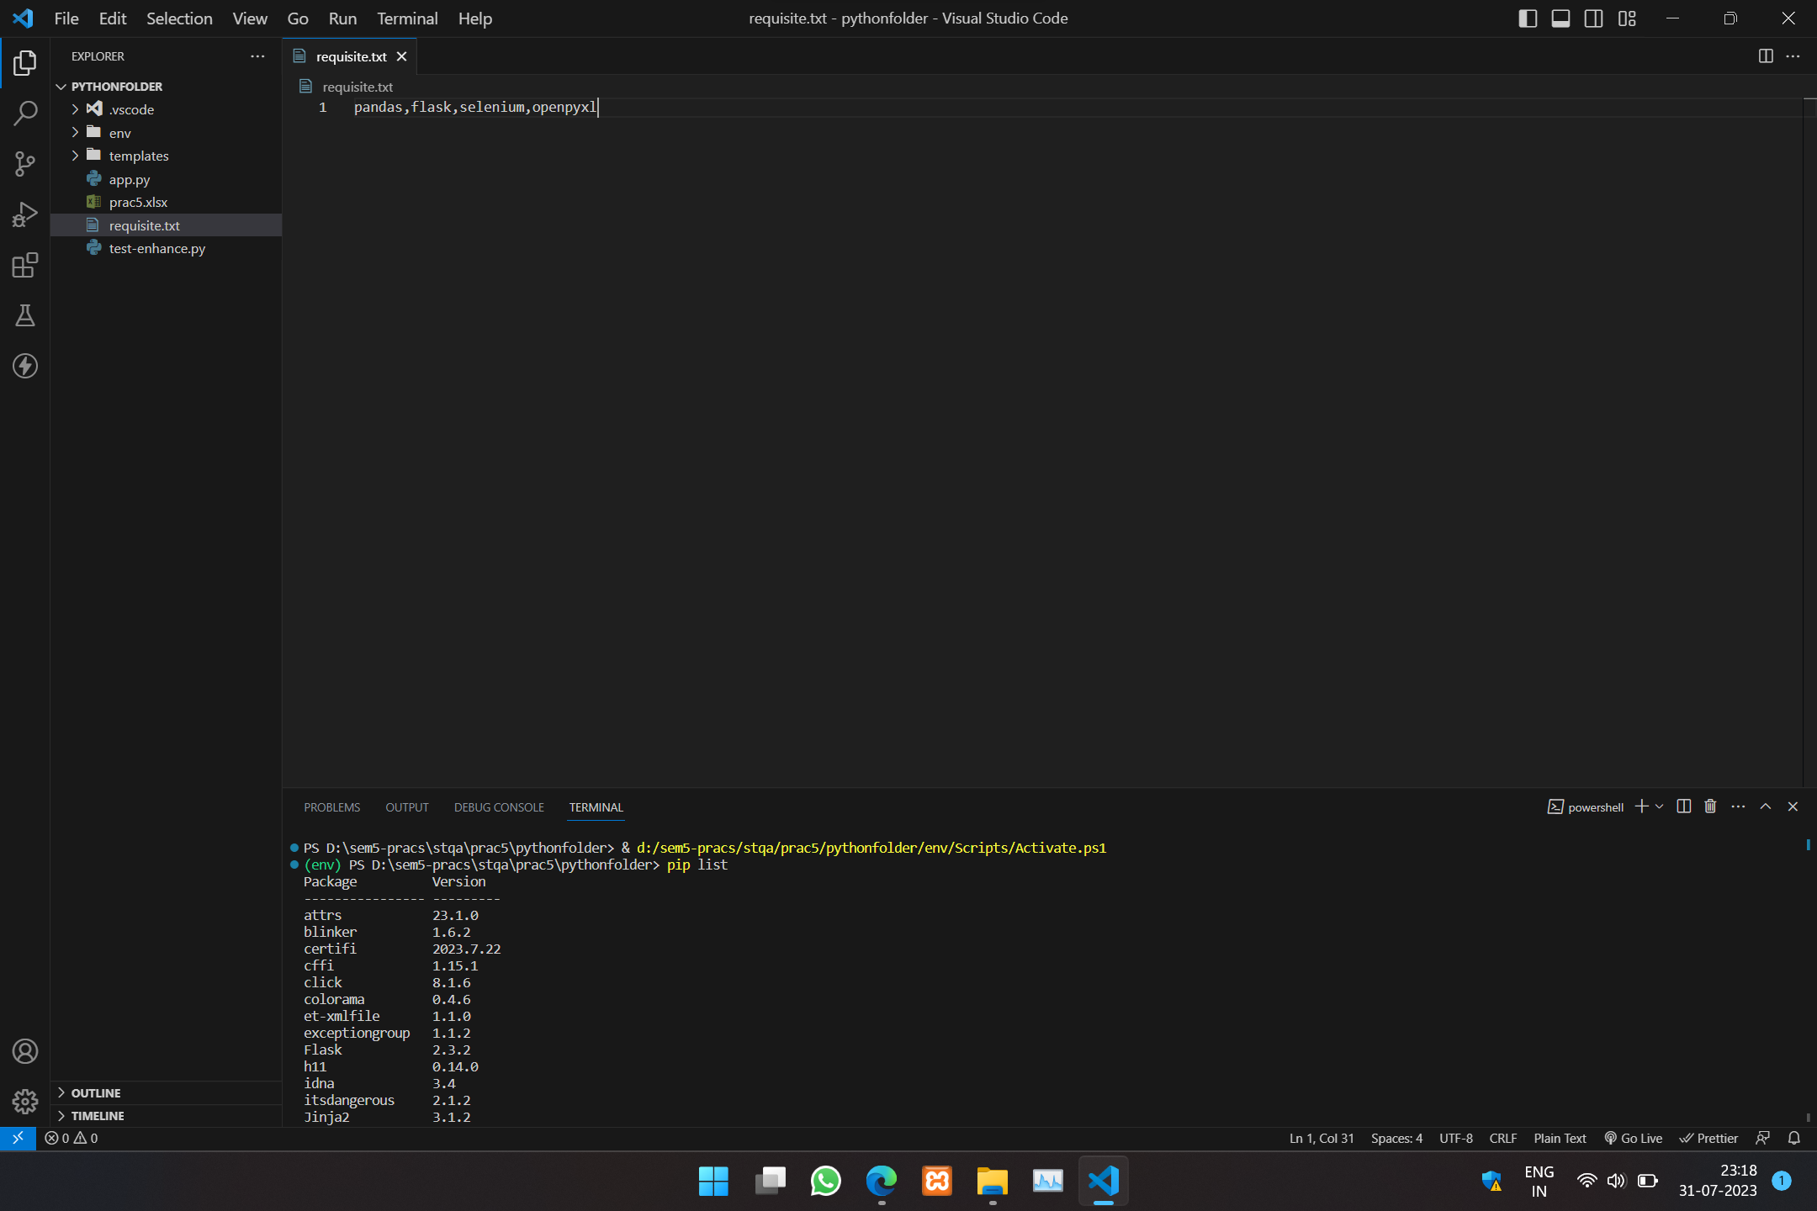

5. Type the following code :

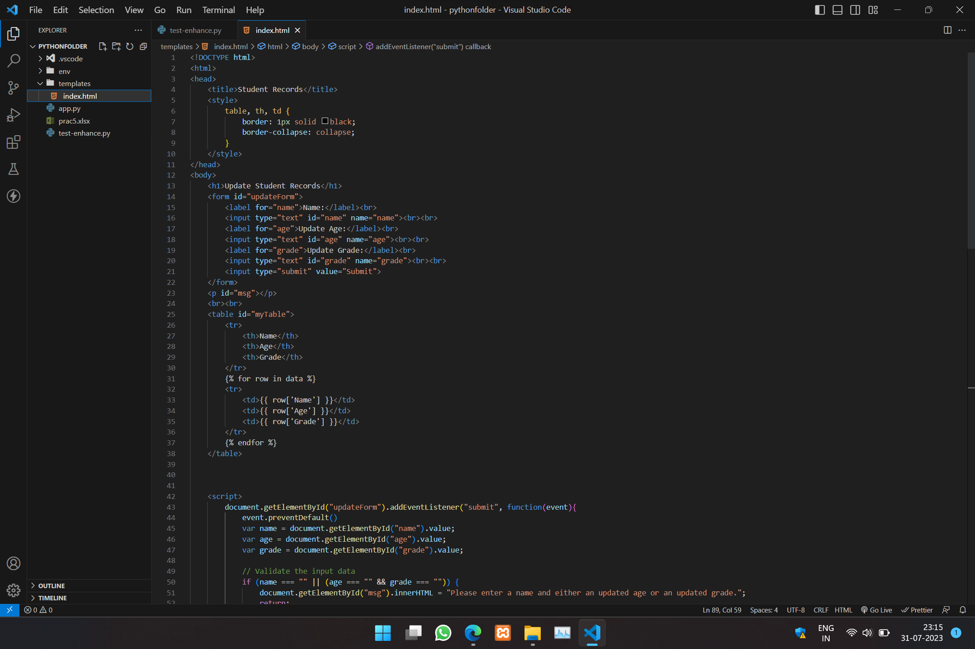

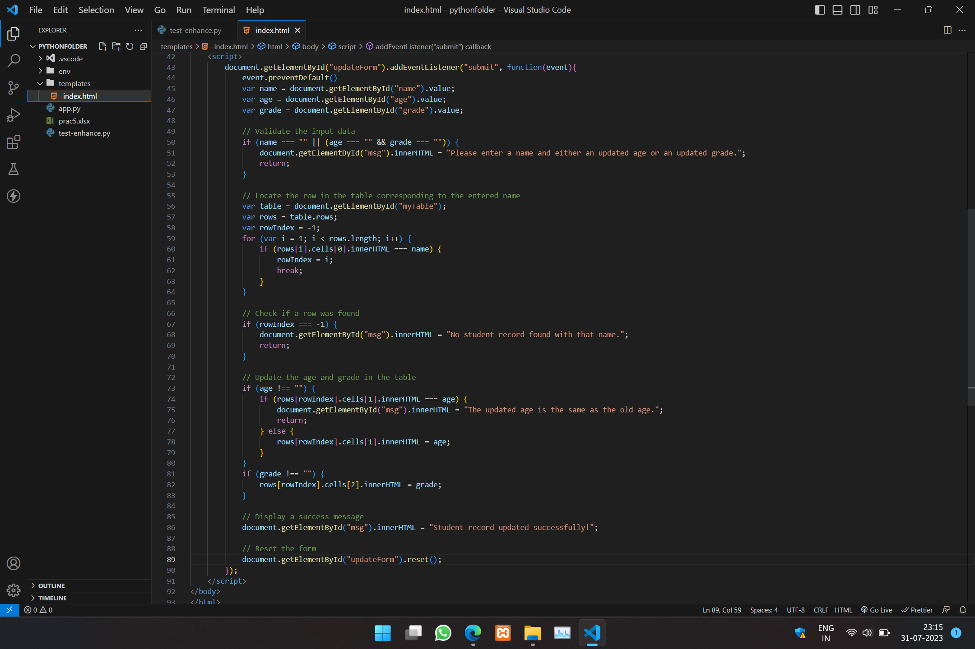

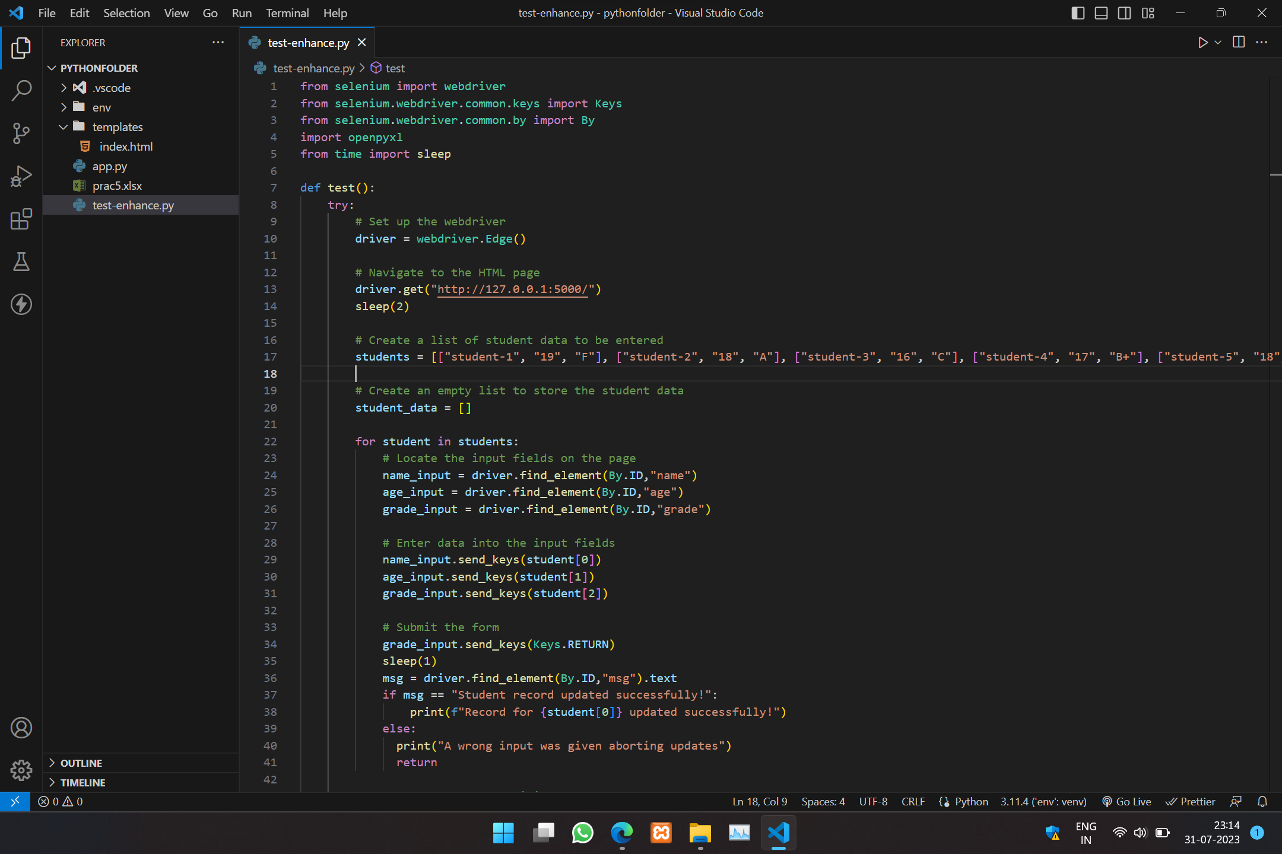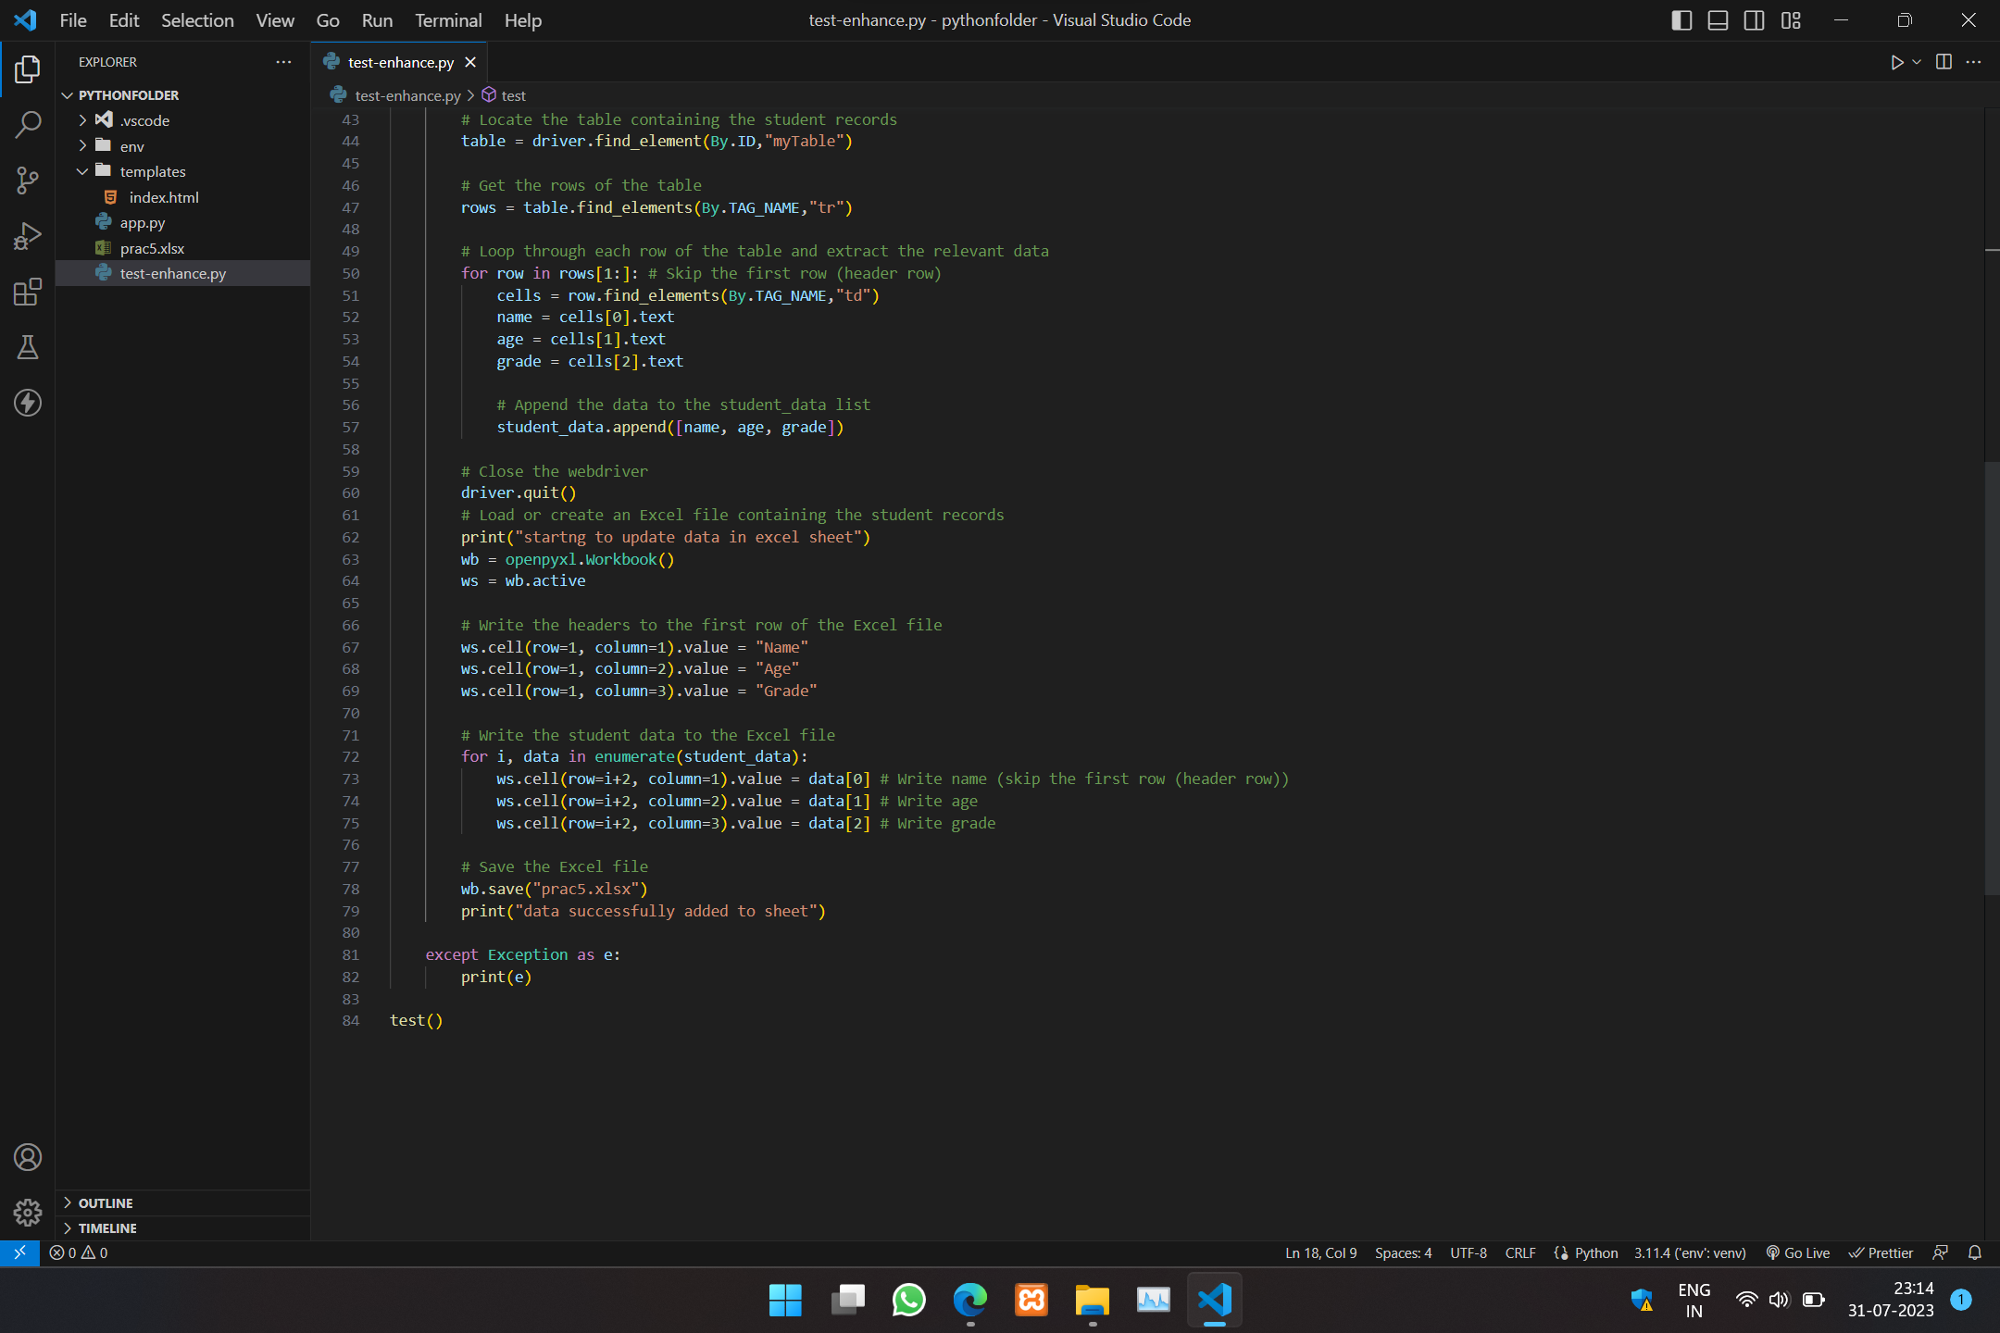6. Open two cmd prompts if vs code is not there

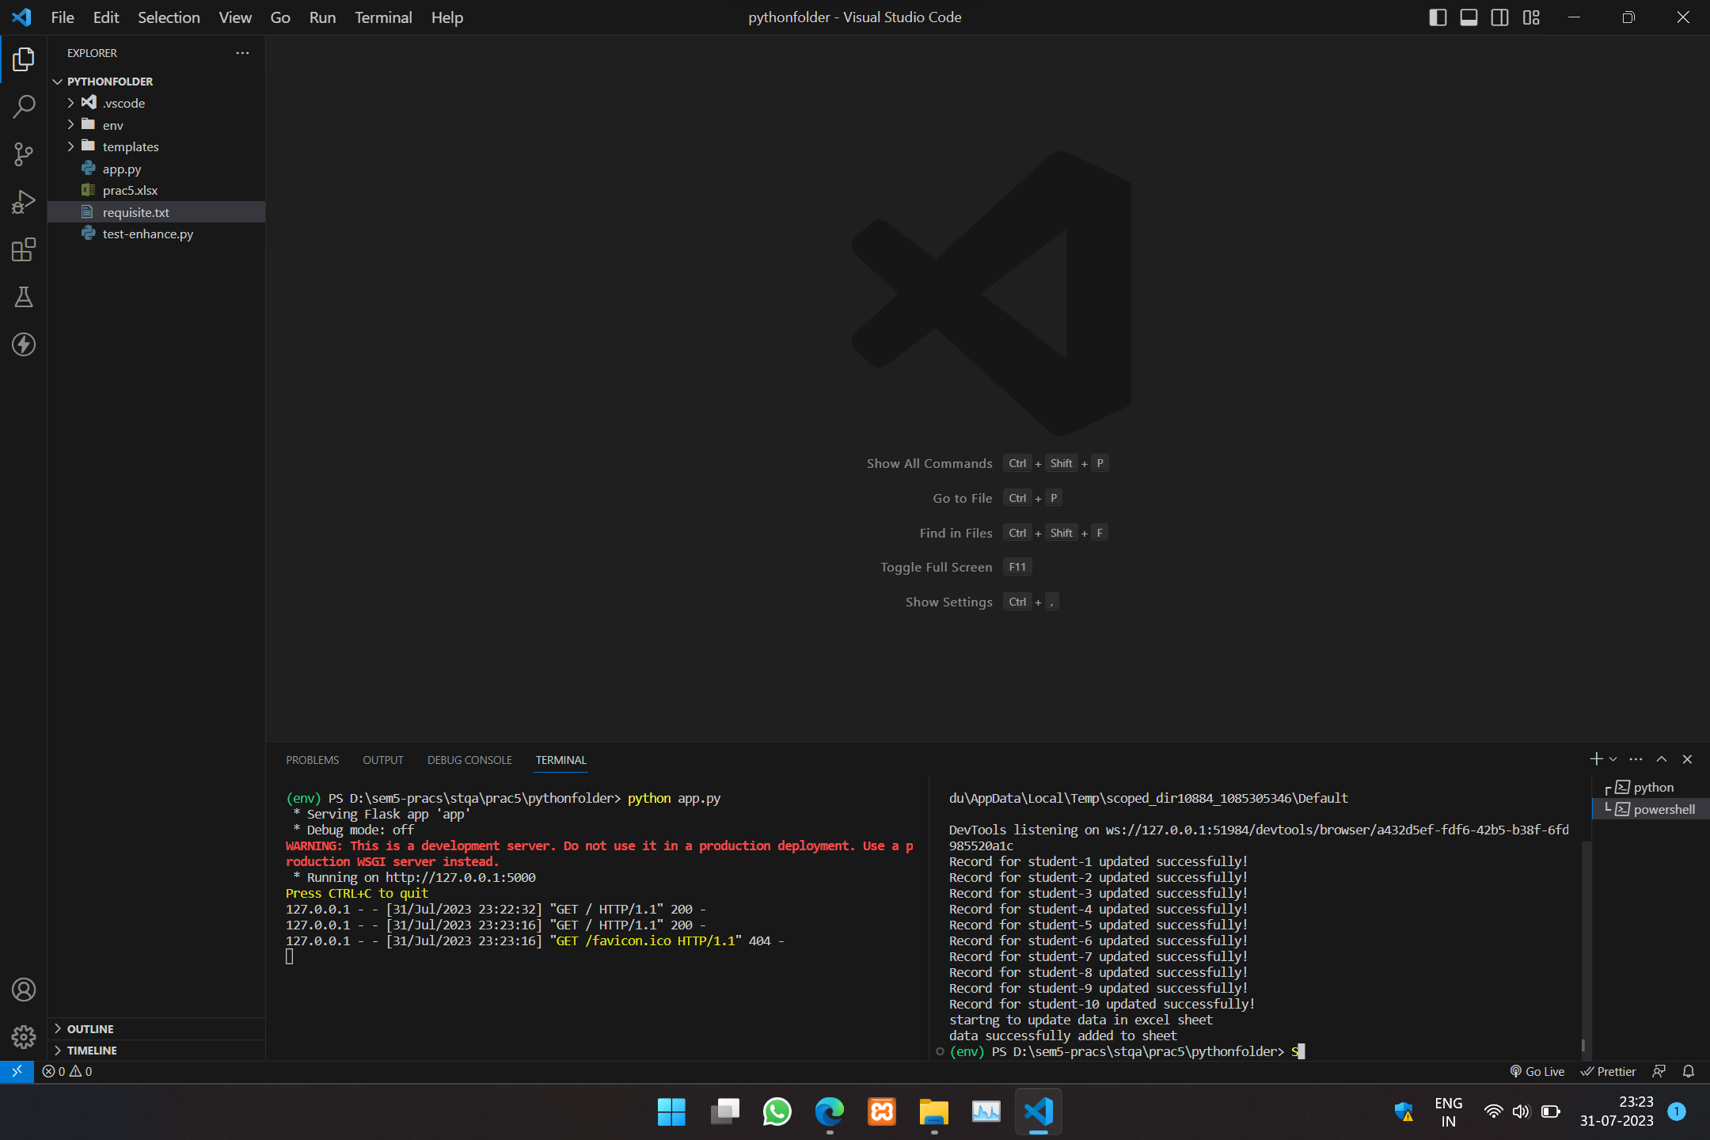

In one terminal execute python app.py (After this u can also visit the link shown in the terminal to see the page)

After that in other terminal type python test-enhance.py

Expect output as :

1. Before running test-enhance.py

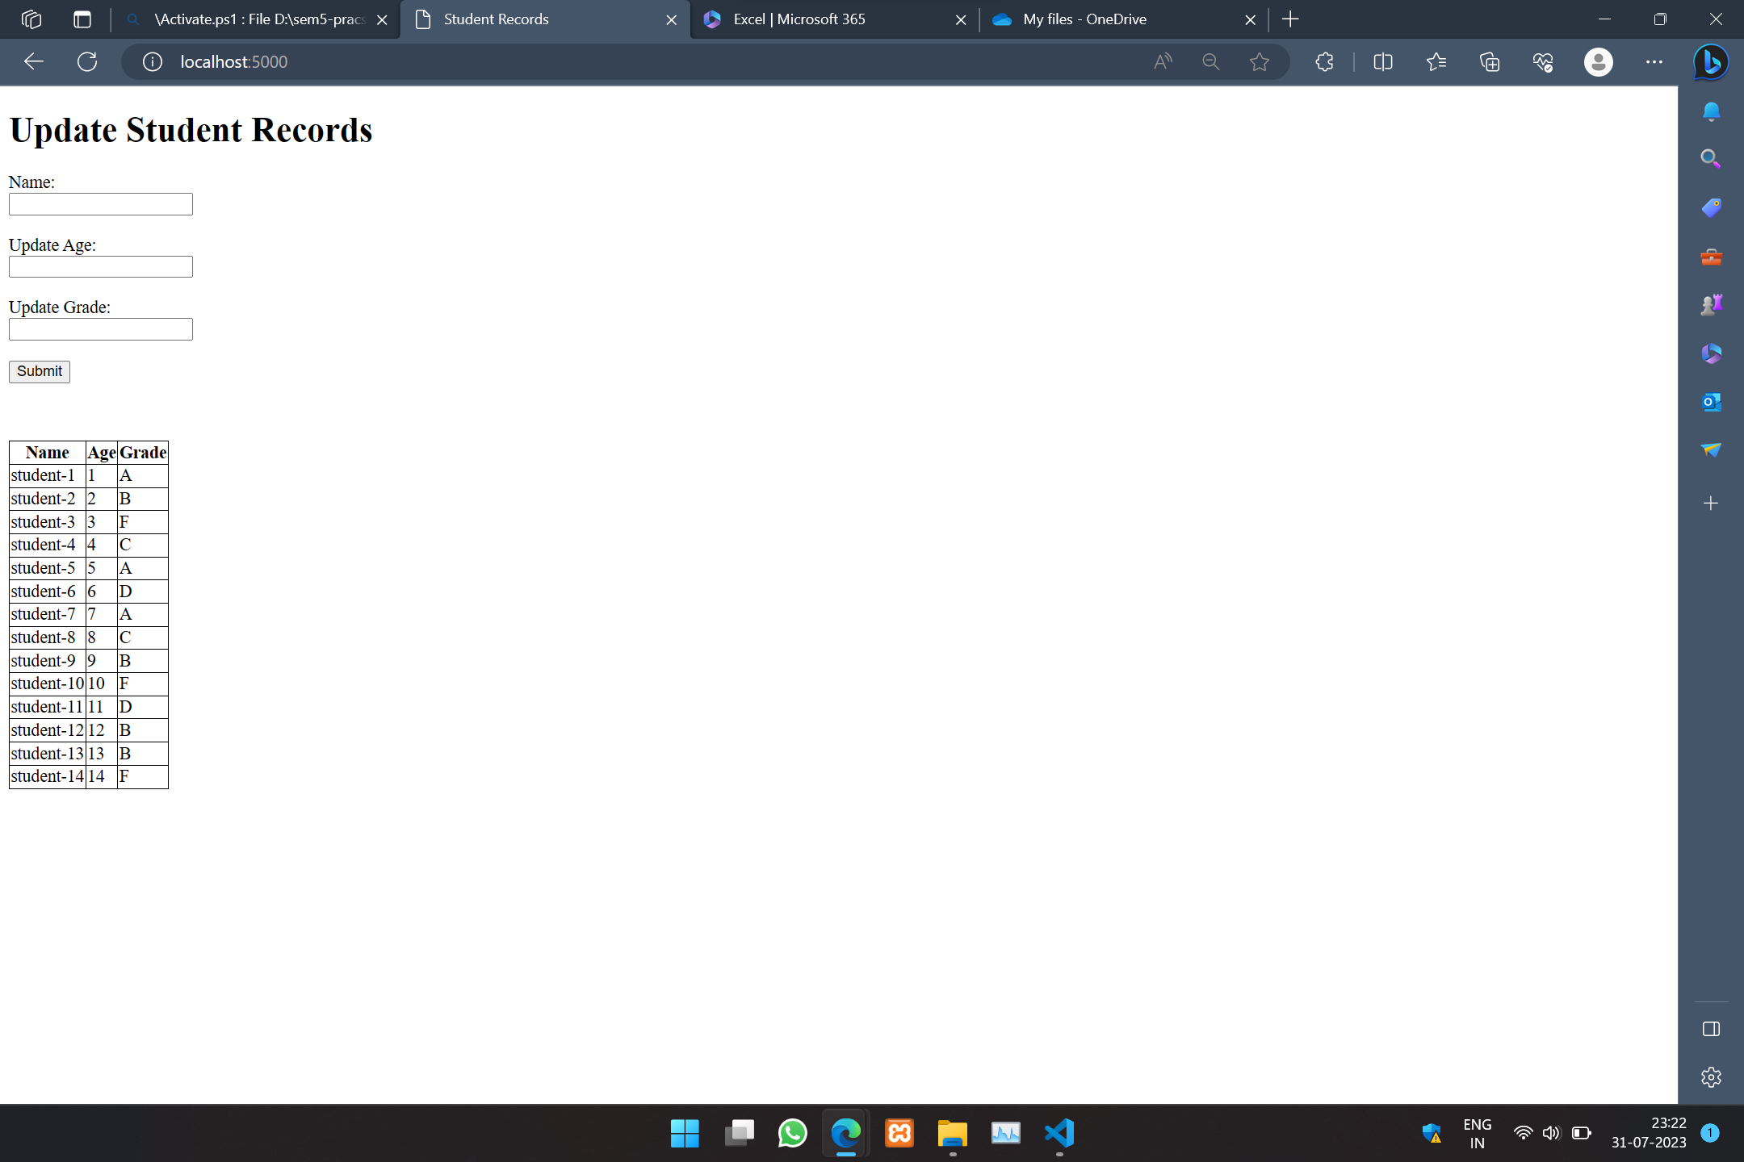

After running test-enhance : -> As the excel file got updated we can see the changes on the page

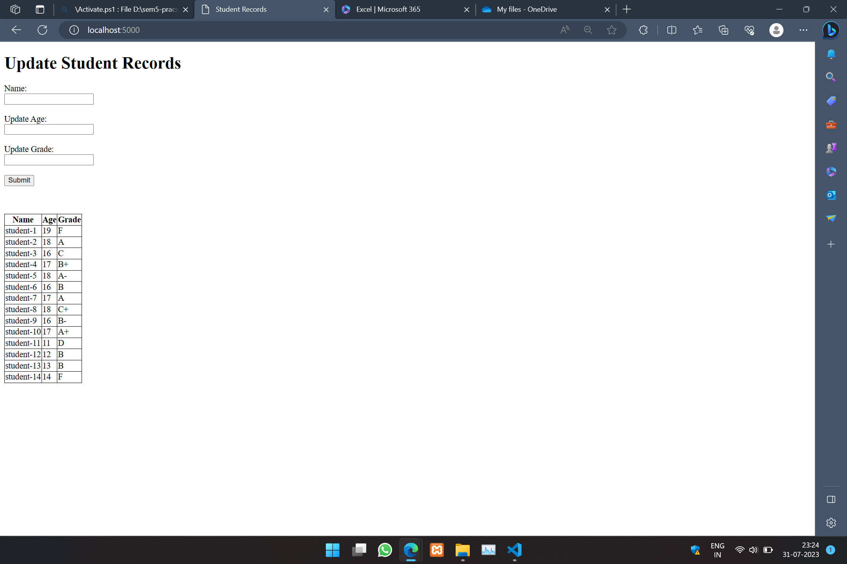

Work Flow:

* First we create a excel file
* Then we try to serve the file to a html page using flask and pandas(it uses openpyxl internally to work with excel file) so that we can use the selenium
* Once our excel file is serve on the html page we can access the data through selenium
* The idea is to update so we have written a JS script that updates the table using dom
* In the execel file I have used Name col as primary index so I havent given the option to update the name column if u notice u can modify as per your choice
* Now as we manipulate the data we also peform some validatin through JS only like checking old and new value and checking if student name exists so our selenium can also perform validation
* At last we run our selenium which submits form and check for validation if the validation criteria is not met it stops there and if all crieteria are met then it updates 10 record and then stores data of the updated record in a array named student_data
* At last using pandas(openpyxl) we flush the appended data to the same execl file